College of Computing and Software Engineering
Annual Review Checklist/Template
v Dec 3, 2024
The purpose of this checklist/template is to support faculty by ensuring they include all necessary information, avoid omissions, and receive full recognition for their achievements and contributions. Additionally, it streamlines the ARD process by promoting uniformity and simplifying submission reviews. Please use this template to complete the narratives. It is required for all annual reviews in the College of Computing and Software Engineering.
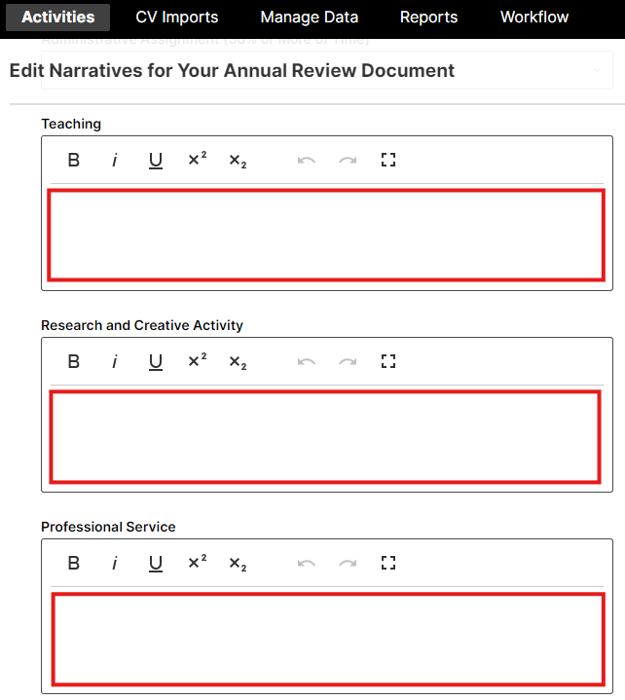
Open CCSE P&T Guidelines https://www.kennesaw.edu/ccse/resources/faculty/college-shared-governance-documents.php
Your academic unit guidelines https://www.kennesaw.edu/ccse/resources/faculty/college-shared-governance-documents.php
CCSE Teaching expectations https://www.kennesaw.edu/ccse/resources/docs/faculty/ccse-faculty-expectations-2-21-2022.pdf
KSU Faculty Handbook https://catalog.kennesaw.edu

Teaching Narrative
Provide a summary that includes an analysis of your teaching performance. Number your responses to align with the corresponding items on this checklist.
- List the FPA teaching goals established for the review year.
- Have you met all expected and mandatory aka basic teaching requirements listed in the unit P&T guidelines?
- What significant aka exemplary aka outstanding teaching activities did you complete?
- Student Success or Course Development Funding like ALG grants provide (Note: Include SoTL grants in S/CA):
  - Internal or external
  - Granting Organization
  - Your role PI or CoPI
  - PI if it is not you
  - Total Amount
  - Start (YY/MM) End (YY/MM)
  - %Effort Assigned to You
  - Amount Realized by You in the reporting year
- For each course you taught in Spring, Summer and Fall semesters include (Note: Combine co-scheduled courses in one entry):
- Semester: Course number Course title (number of students)
- Course modality and if the course was co-scheduled with another section
- Was this course taught as an overload (additional payment)
- Teaching support received (the number of hours for grading help, tutoring, the number of assistant instructors, etc.)
- In addition, use Edit Scheduled Teaching at KSU to provide more information about your teaching.
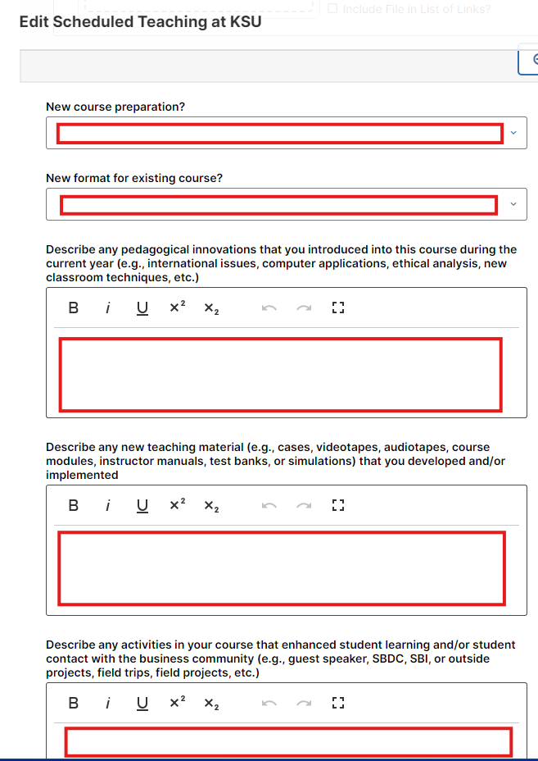

Scholarship/Creative Activities (S/CA)
Summary that includes analysis of your performance in S/CA. Describe your regular aka tier 1 S/CA contributions. Describe your significant aka tire 2 aka outstanding S/CA contributions. Number your responses to align with the corresponding items on this checklist.
- List the FPA S/CA goals established for the review year.
- Support provided for your S/CA
  - GRA support #hours per week, source of the funding and the results achieved
  - Internal grants
- Publications. Do not include any accepted publications. For each submitted and published publication you put in the Watermark provide (do not include accepted and not published):
- Was this publication included in the previous year's ARD as submitted publication?
- Impact factor/quality and significance
- How your publication aligns with the college and academic unit goals.
- % of effort
- New funding this year. For each new grant specify
- Internal or external
- Granting Organization
- Your role PI or CoPI
- PI if it is not you
- Total Amount
- Start (YY/MM) End (YY/MM)
- %Effort Assigned to You
- Amount Realized by You in the reporting year
- Continuing Grants. For each continuing grant that produced revenue in the year under review list
- Internal or external
- Granting Organization
- Your role PI or CoPI
- PI if it is not you
- Total Amount
- Start (YY/MM) End (YY/MM)
- %Effort Assigned to You
- Amount Realized by You in the reporting year
- Grants Rejected For each rejected grant list:
- Internal or external
- Granting Organization
- Your role PI or CoPI
- PI if it is not you
- Total Amount
- Start (YY/MM) End (YY/MM)
- %Effort Assigned to You
- How much time did you spend writing this grant? Do you have plans to resubmit? What improvements are you going to make? Submit rejection letter with reviewers’ feedback if you would like to count this effort in your S/CA workload
- Grants under review. List all the grants that were submitted but not awarded or rejected in the year under review.
- Dissertation or Thesis Committees. For each entry list:
- Student’s Name
- Student’s major
- Student’s department and college
- MS or PhD thesis
- Were you the Committee Chair? (Y/N)
- Your contribution and # of hours
- Other Contributions. Include other contributions like invited talks, awards, etc. Comment on the quality and significance.

Professional Service
Summary that includes your analysis of your performance in service. Number your responses to align with the corresponding items on this checklist.
- List the FPA professional service goals established for the review year.
- Have you met all expected and mandatory service requirements?
- What significant aka exemplary aka outstanding service activities did you complete?
- KSU Events Attended: Include such events as the Hackathon, Commencement, C-Day, and Analytics Day. Also, any special activities such as Open Houses and list how you contributed to the event.
- Committees: Attending meetings without contribution does not count. For each committee include:
- Committee name and your role
- The number of hours you spent
- What contributions did you make?
- College and academic unit service other than committees: Describe all services you provided to the college/unit e.g. course coordination, websites, clubs. Include quality and significance of each activity and % effort.
- External Service: Include visits to schools, science fair judging, and any other activities that help promote KSU to the community.
- Service to Professional Organizations: Include conference organization, chairing sessions, serving on professional committees, or standards organizations.
- Special Administrative Duties over the required 10% of service: If you held any special administrative position for which you received an additional service workload, please describe the duties that you carried out and the results of your efforts. Also indicate how many students/faculty you worked with in the course of your duties.

